NOTICE OF PUBLIC AUCTION

SPECIAL COMMISSIONER’S SALE OF REAL ESTATE

COUNTY OF RUSSELL, VIRGINIA

Pursuant to the terms of those certain Decrees of Sale entered in the Circuit Court of County of Russell, the undersigned Special Commissioner will offer for sale at a simulcast (with online and in person bidding) public auction the following described real estate at 139 Highland Drive, Lebanon, Virginia, 24266, on May 20, 2024 at 10:00am.

The sale of such property is subject to the terms and conditions below, and any term or conditions which may be subsequently posted or announced by Mitch-Ell Auction Firm (“Auctioneer”) and Taxing Authority Consulting Services, PC (“TACS”). Subsequent announcements take precedence over any prior written or verbal terms of sale.

 | Property Owner(s) | Tax Map No. | TACS No. | Property Description
J1.1 | Gary Holbrook | 115R-IA-1002 | 467726 | 1939 New Garden Road; Sutherland Farm Subv.; Castlewood Magisterial District
J1.2 | Gary Holbrook | 115R-IA-1003 | 467726 | Sutherland Heights; Castlewood Magisterial District
J2 | Rhonda Patrick | 159R-ID-2294 | 158441 | 107 Cigarette Hollow; Lot 169; Dante Subv. D; Castlewood Magisterial District
J3 | Boyd and Stella Dishman | 159R-IC-2251 | 158433 | 35 Brandy Hollow Road; Dante, Lot 140; Castlewood Magisterial District
J4 | Richard Wayne Crouse | 33L-SA-2657A1 | 158619 | Swords Creek Road; Mill Creek; New Garden Magisterial District
J5 | Lafayette Hartsock | 160R-IH-2468 | 699423 | 895 Straight Hollow; Lots 383, 384; Subv. I; Castlewood Magisterial District
J6 | Paul Smith Estate | 104L-2794B | 468409 | Glade Hollow, 3 AC residual Por. Of 5 acre tract; Lebanon Magisterial District
J7 | Jack Duncan | 115L-IA-47 | 808289 | 6557 Cleveland Road; Cleveland, Lot 2 & 3 Part of 4; Castlewood Magisterial District
J8 | Mary Plaster | 157R-IC-2642 | 468148 | 148 Morefield Bottom Drive; East Morefield; Lot 140 BLK 4; Castlewood Magisterial District
J9 | Daniel Scott Hokanson | 140R-664 | 808374 | 4016 Reeds Valley Road; Reeds Valley Lot; Castlewood Magisterial District
J10 | Sammy Hawkins | 138R-2342 | 158005 | 34 Davis Memorial Drive; Moccasin Ridge; Lebanon Magisterial District
J11 | Marvin Peck | 33L-2589 | 467693 | 2147 Mill Creek Road; Mill Creek; New Garden District

GENERAL TERMS OF SALE: All sales are subject to confirmation by the Circuit Court. The Special Commissioner has the right to reject any bids determined to be unreasonable in relation to the estimated value of the Property. Any unsold property will be offered for sale again at the next auction, whenever that may be.

Properties are conveyed by Special Warranty Deed, subject to any easements, covenants, agreements, restrictions, reservations, and any and all rights of record which may affect the property. Properties are offered for sale as-is, where-is, and if-is, with all faults and without any warranty, either expressed or implied. Persons are encouraged to make a visual inspection of the property within the limits of the law and to obtain an independent title search, at their own expense, prior to bidding on any of the properties to determine the suitableness of the property for their purposes. It is not guaranteed that the property has a right-of-way or that it is not landlocked. Property is sold in gross and not by the acre. There is no warranty as to the accuracy of any information contained in the GIS system, nor is the information contained therein a legal representation of any of the features of the property which it depicts. We do not provide and do not assist with obtaining title insurance or title to personal property.

The sale of property to the highest bidder is not contingent upon obtaining financing. Financing, if needed, is the sole responsibility of the high bidder. By bidding, parties are entering into a legally binding contract, waive all rescission rights, and understand that their bid is immediately binding, irrevocable, and enforceable. Additionally, by bidding, parties are representing that they have read, and agree to be bound by, all terms and conditions for this sale. Failure to complete the property purchase will result in forfeiture of any funds paid and may subject the highest bidder to additional damages, which may include expenses and any deficit upon resale.

PAYMENT TERMS: The highest bidder shall make a deposit in the amount of twenty-five percent (25%) or One Thousand Dollars ($1,000.00), whichever is higher, along with a 10% buyer’s premium, subject to a minimum of $150, added to the final bid. Bids which are less than One Thousand Dollars ($1,000.00) shall be paid in full at the time of the auction. Deposits shall not exceed Twenty Thousand Dollars ($20,000) per parcel. Such sum shall be held by the Special Commissioner and credited towards the purchase price following confirmation of the sale. Subsequent taxes will be prorated from the auction date, and the highest bidder will be responsible for taxes from that date forward.

The balance of the purchase price and recording costs for deed recordation shall be deposited by the highest bidder with the Special Commissioner within fifteen (15) days of confirmation of the sale by the Court.

Terms applicable to In-Person Bidders ONLY: The deposit and buyer’s premium are due on the day of the auction. All payments must be made in the form of personal check, cashier’s check or money order. No cash will be accepted.

Terms applicable to Online Bidders ONLY: All interested parties must register and be approved by the Auctioneer. Registration and bidding are free of charge and are done through the Auctioneer’s website www.mitchellauctionfirm.com. If any interested bidders are unable to attend for in-person bidding and wish to bid on property, but do not have access to the internet, please contact Mitch-Ell Auction Firm, at (276) 608-4786 for assistance.

The highest bidder will receive their purchase contract and balance due via email following the close of the auction. The contract shall immediately be executed and returned to TACS. The deposit and buyer’s premium must be received in full within seven (7) days following the auction closing (no later than May 28, 2024). All payments must be made in the form of certified funds, cashier’s check, money order or wire transfer. Cashier’s checks and money orders shall be made payable to County of Russell and forwarded to TACS, at the address shown below. Cash and personal checks will not be accepted. Wire transfer instructions will be provided to the highest bidder upon request.

GENERAL TERMS: To qualify as a purchaser at this auction, you may not owe delinquent taxes to County of Russell and you may not be a Defendant in any pending delinquent tax matter. Questions concerning the registration and bidding process should be directed to the Auctioneer online at www.mitchellauctionfirm.com, by email to mark@mitchellauctionfirm.com or by phone to Mark Mitchell, at (276) 608-4786. Questions concerning the property subject to sale should be directed to TACS online at www.taxva.com, by email to taxsales@taxva.com, by phone to 804-506-3102, or by writing to the address below.

Taxing Authority Consulting Services, PC
Attn: Tax Sales
P.O. Box 31800
Henrico, Virginia 23294-1800
USA

SAMPLE AUCTION CONTRACT

At that certain real estate tax sale which closed on Monday, May 20, 2024, the undersigned was the highest bidder on the real estate described below, for a bid price of $____________________.

Case Name: County of Russell v. ___________________ (Case No. ______________)

Tax Map Number:

Account Number:

TACS Number:

Buyer’s Premium: $_______________________

Bid Deposit: $_______________________

Credit Card Hold: $(______________________)

Total Due Now: $_______________________

I understand that the above-referenced “Total Due Now” is required to be deposited today with the Special Commissioner and that the balance of the high bid and the deed recordation cost will be due within fifteen (15) days after confirmation of this sale by the Circuit Court of the County of Russell, Virginia. I understand that in the event my payment is returned or otherwise does not clear within twenty (20) days, this contract of sale may be voided, I may be responsible for damages or costs of resale, and the next highest bidder may be contacted to purchase the property.

I understand that this property is being sold subject to any covenants, easements, agreements, restrictions, reservations, conditions of record, and any claims of persons in possession. I understand that this property may not have a right-of-way to a public road, and I hereby accept this limitation. I understand that I will be notified at the address below of the date the Special Commissioner intends to ask the Court to confirm this sale, and that this Court hearing will be my last opportunity to raise any questions concerning this sale. I understand that this property is offered for sale as-is, with all faults and without any warranty, either expressed or implied, and I confirm that I have satisfied myself as to the property’s existence and location prior to the execution of this contract.

I understand that I will be responsible for any real estate taxes on this parcel from the date of sale (May 20, 2024). I further understand that in the event I owe delinquent taxes to or am named as a Defendant in any delinquent tax suit filed by the above-named locality, that this contract shall be voidable and I agree to forfeit any right, title or interest that I may have in the real estate to the next highest bidder as listed in the auction documents.

I understand that if I fail to comply with this Purchaser’s Acknowledgement and Contract of Sale, or if the balance of the purchase price is not paid in full within fifteen (15) days of confirmation, I agree to forfeit all amounts paid and pay any charges incurred by the Special Commissioner or the Court in collecting on the delinquent amount, that this real estate may be resold, and that I will be responsible for any deficiency upon resale.

I understand that by bidding, I have entered into a legally binding contract and that I waive all rescission rights. I understand that my bid was immediately binding, irrevocable, and enforceable.

I understand that the former owner(s) of this property may for good cause shown, within ninety (90) days from the entry of the Decree of Confirmation in this matter, petition the Court to have the matter reheard. I understand that title to the property described herein will be taken in the name(s) indicated below and I represent that I have the authority to purchase and title the property in the name(s) shown below.

____________________________________ ____________________________________
Signature Street Address

____________________________________ ____________________________________
Name (please print) City, State, Zip

____________________________________ ____________________________________
Telephone Email Address

Title will be taken in the name of:

______________________________________________________________________________

Type of Interest:  Tenants in Common  Tenants by Entirety with ROS  Joint Tenants  None

CERTIFICATION

It is hereby certified that the above-referenced purchaser has, on this 2nd day of October, 2023, acknowledged and executed the foregoing Purchaser’s Acknowledgment and Contract of Sale. I further certify that the contact information and signature shown above belong to the aforementioned purchaser and are true and correct to the best of my knowledge.

____________________________________
Taxing Authority Consulting Services, PC

J1- Gary Holbrook
TACS # 467726 Tax Map Number 115R-IA-1002 & 115R-IA-1003

USA
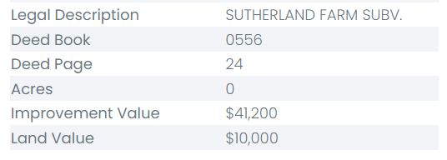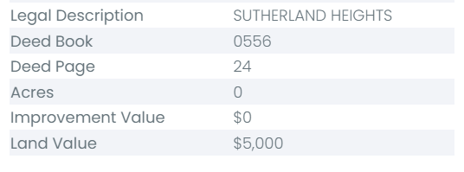

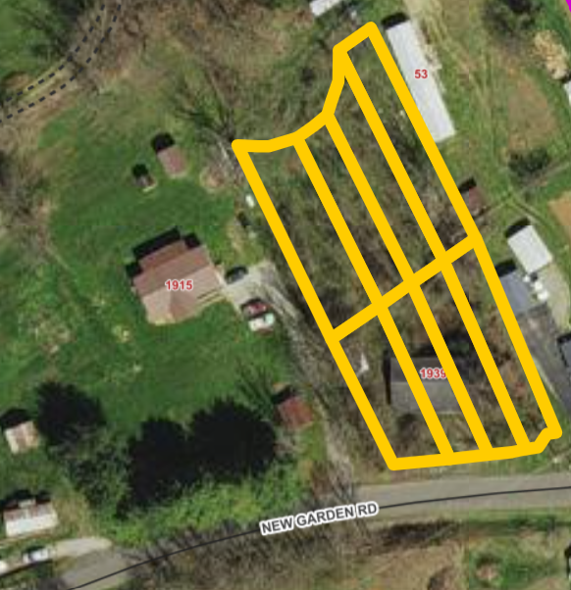

DISCLAIMER: The information on this page is NOT to be used as a LEGAL DOCUMENT. The map information displayed is believed to be accurate, but accuracy is not guaranteed.

J2- Rhonda Patrick
TACS # 158441 Tax Map Number 159R-ID-2294
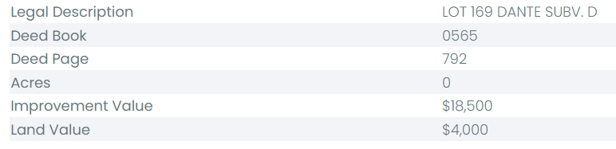

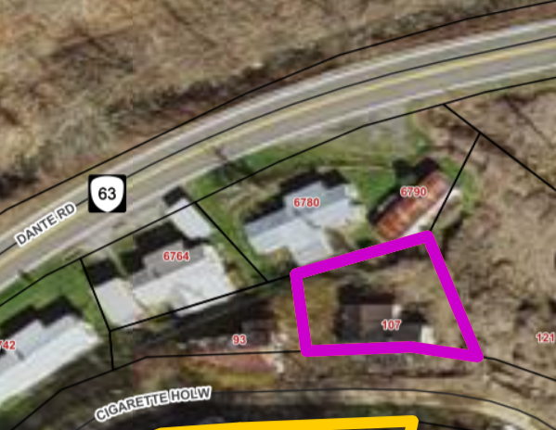
DISCLAIMER: The information on this page is NOT to be used as a LEGAL DOCUMENT. The map information displayed is believed to be accurate, but accuracy is not guaranteed.

J3- Boyd and Stella Dishman
TACS # 158433 Tax Map Number 159R-IC-2251

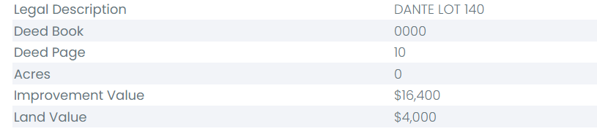
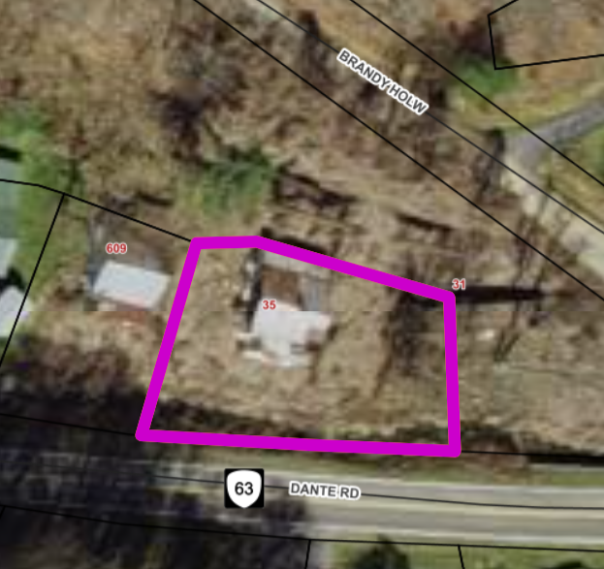

DISCLAIMER: The information on this page is NOT to be used as a LEGAL DOCUMENT. The map information displayed is believed to be accurate, but accuracy is not guaranteed.

J4- Richard Wayne Crouse
TACS # 158619 Tax Map Number 33L-SA-2657A1

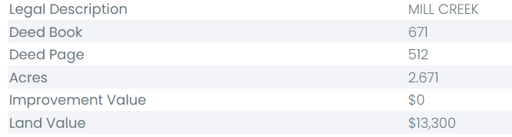

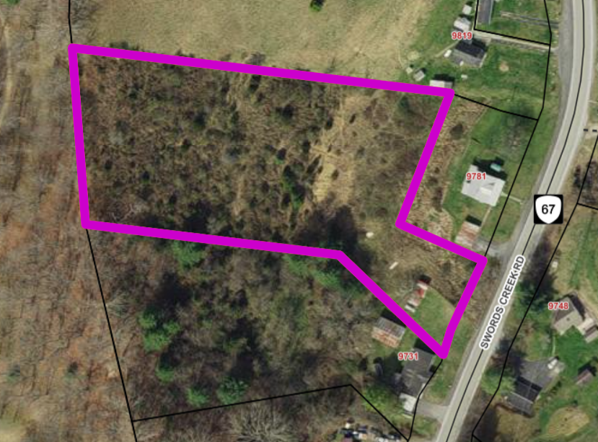 DISCLAIMER: The information on this page is NOT to be used as a LEGAL DOCUMENT. The map information displayed is believed to be accurate, but accuracy is not guaranteed.

J5 – Lafayette Hartsock
TACS # 699423 Tax Map Number 160R-IH-2468

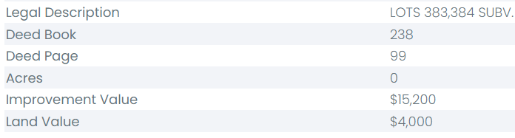
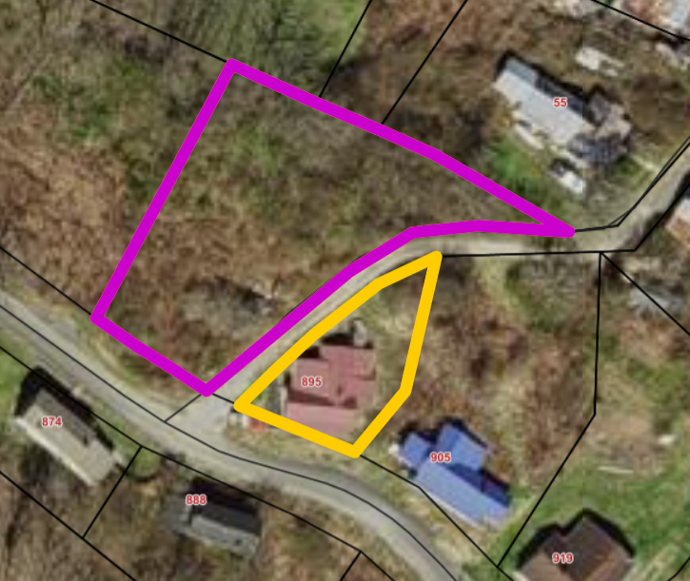

DISCLAIMER: The information on this page is NOT to be used as a LEGAL DOCUMENT. The map information displayed is believed to be accurate, but accuracy is not guaranteed.

J6- Paul Smith Estate
TACS # 468409 Tax Map Number 104L-2794B

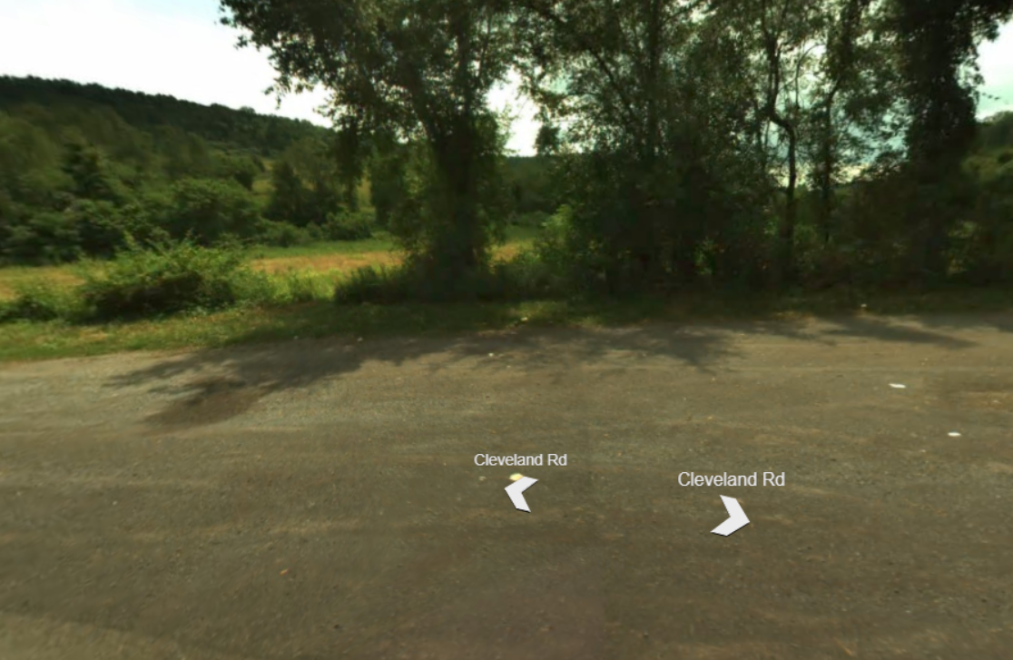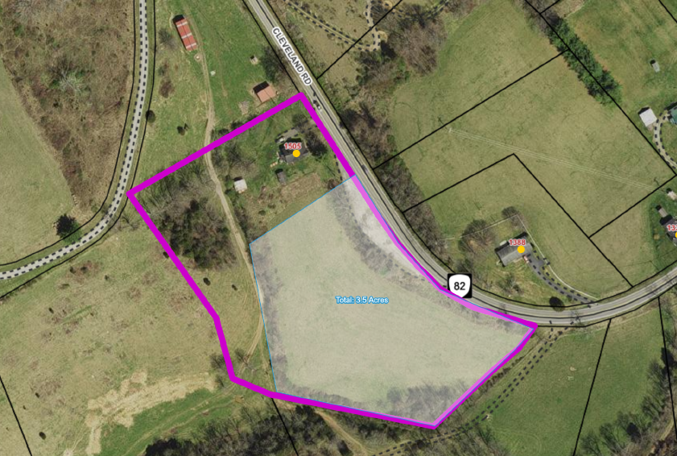
Near 1505 Cleveland Road, Cleveland

DISCLAIMER: The information on this page is NOT to be used as a LEGAL DOCUMENT. The map information displayed is believed to be accurate, but accuracy is not guaranteed.

J7- Jack Duncan
TACS # 808289 Tax Map Number 115L-IA-47

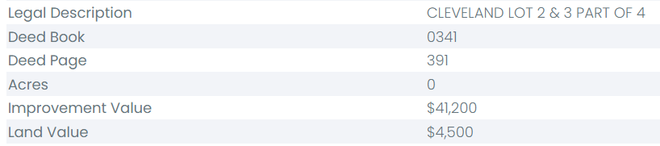

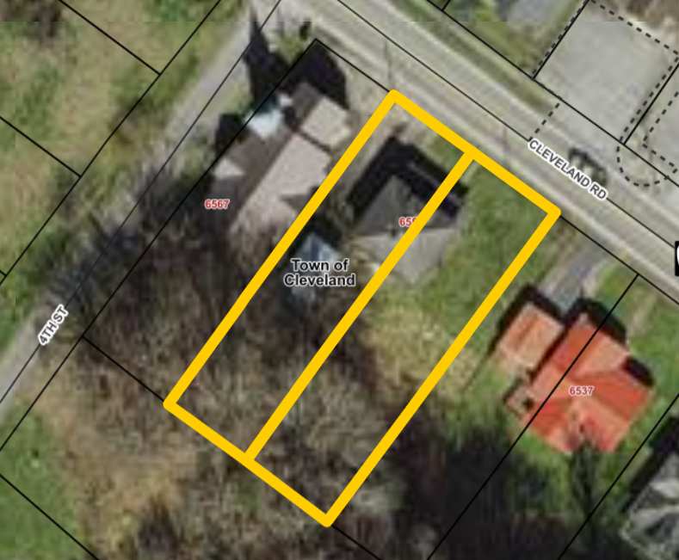

DISCLAIMER: The information on this page is NOT to be used as a LEGAL DOCUMENT. The map information displayed is believed to be accurate, but accuracy is not guaranteed.

J8- Mary Plaster
TACS # 468148 Tax Map Number 157R-IC-2642
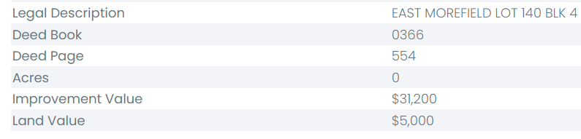

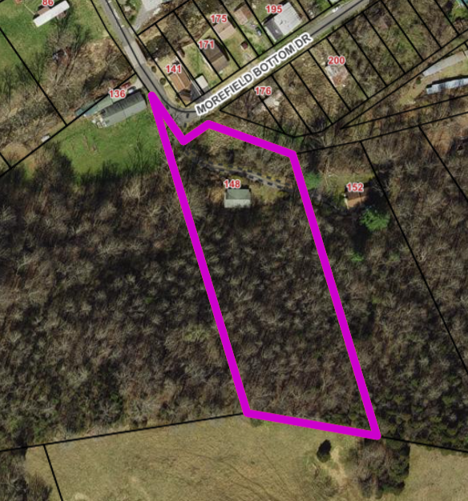

DISCLAIMER: The information on this page is NOT to be used as a LEGAL DOCUMENT. The map information displayed is believed to be accurate, but accuracy is not guaranteed.

J9- Daniel Scott Hokanson
TACS # 808374 Tax Map Number 140R-664
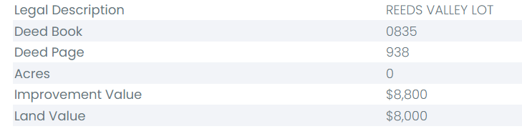

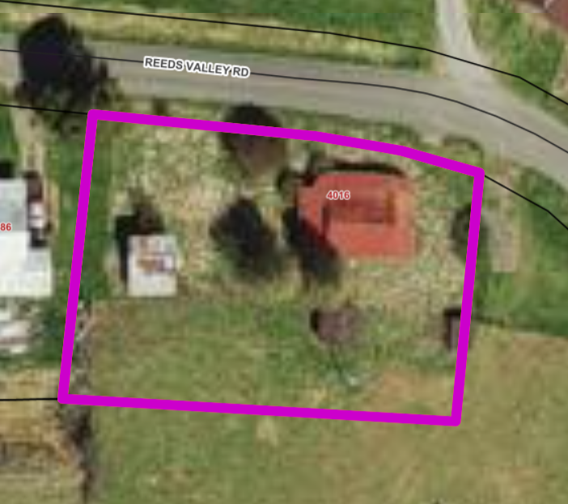

DISCLAIMER: The information on this page is NOT to be used as a LEGAL DOCUMENT. The map information displayed is believed to be accurate, but accuracy is not guaranteed.

J10- Sammy Hawkins
TACS # 158005 Tax Map Number 138R-2342
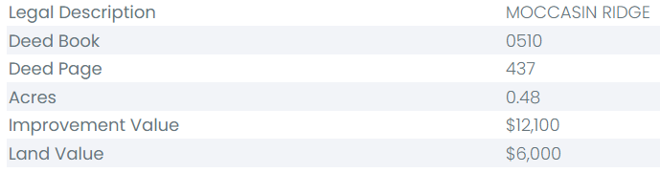
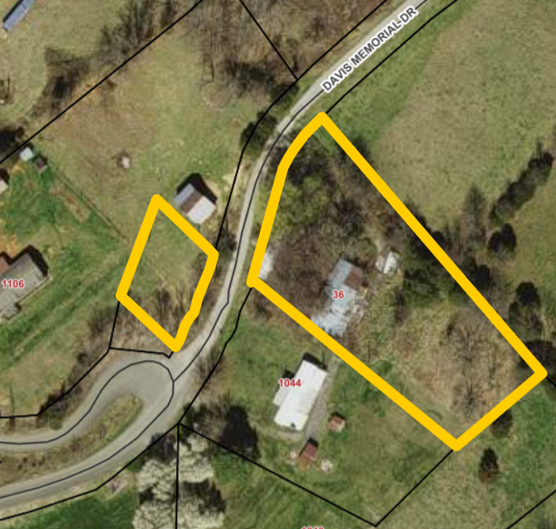
DISCLAIMER: The information on this page is NOT to be used as a LEGAL DOCUMENT. The map information displayed is believed to be accurate, but accuracy is not guaranteed.

J11- Marvin Peck
TACS # 467693 Tax Map Number 33L-2589
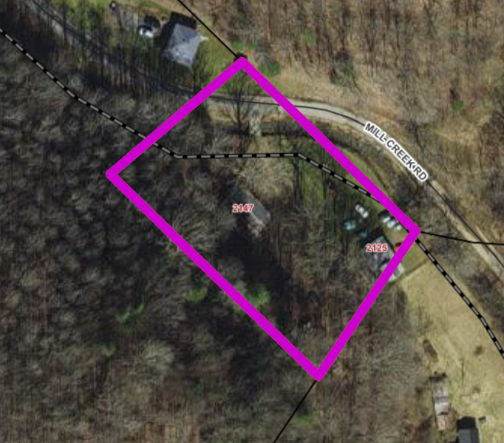 DISCLAIMER: The information on this page is NOT to be used as a LEGAL DOCUMENT. The map information displayed is believed to be accurate, but accuracy is not guaranteed.

